
Wheelchair Assessment and Prescription Form 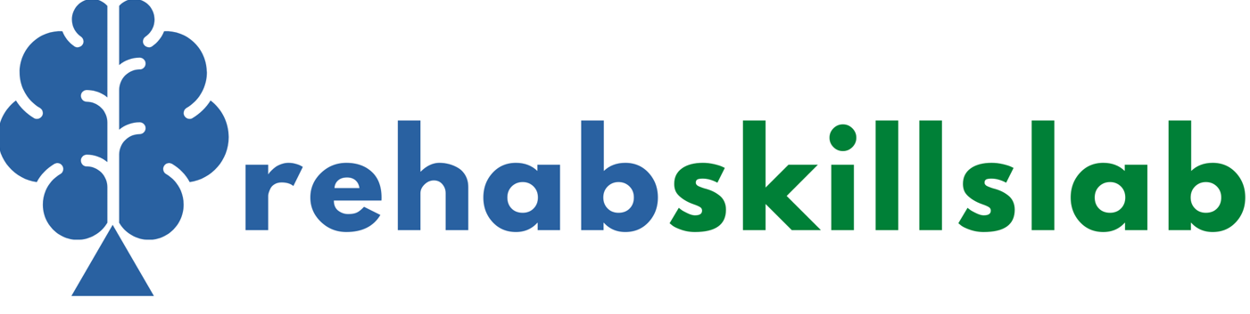

Name |  | Centre
Home address (incl. city, province and country) |  | Centre Address
Hospital |  | Assessment date
Folder Number |  | Assessor
Date of Birth |  | Profession (assessor)
Contact number |  | Funding: Government (circle): DOH DOE DSD SAPS SANDF Medical Aid
Name of caregiver |  | Individual Funder Medico-legal (circle): RAF WCA Other
User/caregiver goals and concerns:
Medical Information
Diagnosis:
ICD 10 codes (if available):
Past Medical History | Present Medical History
Medication:

ICF Assessment – as related to wheelchair use
Activity Limitations  What actions/tasks can the client not do independently? What actions or tasks can the client nearly do? |  |  | Participation Restrictions  What problems are experienced in being included in daily activities, making decisions, family situations, community activities?
Personal Factors  What factors specific to the client are influencing their participation? (age, weight, gender, motivation, behavior, stage of play, likes/dislikes) |  |  | Functional Goals  What goals are the client/family working on for the next 6 months? What are the next steps to see improvement?
Environmental Factors
What factors outside of their control are impacting on the client’s participation? (family, cultural, physical environment, finances, school, friends, parent’s education)
Transportation | Travel sitting in wheelchair |  | Car (passenger) |  | Car (driver)
Public Transport | Bus | Taxi |  | Train |  | Pedestrian
Other:
General Function
Communication | Verbal | Difficult to understand | Non-verbal | AAC user
Feeding | Independent | Assists | Unable | Equipment
Toileting | Toilet | Commode | Nappies | Other:
Bladder optimally managed? | Yes | No | Comments:
Bower optimally managed? | Yes | No | Comments:



Details of current wheelchair seating system / posture support device Not applicable

Length of time current device used:
Wheelchair is in a good condition
Yes | No | If no, comment:
Wheelchair meets the user’s functional needs
Yes | No | If no, comment:
Wheelchair meets the user’s environmental needs
Yes | No | If no, comment:
Wheelchair provides proper fit and postural support
Yes | No | If no, comment:
Cushion is in a good condition
Yes | No | If no, comment:
Cushion provides proper postural support
Yes | No | If no, comment:
Cushion provides proper pressure relief (for users with pressure risk)
Yes | No | If no, comment:


Wheelchair Function
Mode of propulsion | Upper limbs | Lower limbs |  | Upper & Lower limbs |  | Assistant |  | Powered
Manual mobility skills | Indoors |  |  |  | Outdoors
Manual mobility skills | Independent |  | Limited |  | Independent |  | Limited |  | Advanced
Transfers | Independent |  |  |  | Assisted
Transfer type | Standing | Sitting |  | Lifted |  | Other:
If lifted | One person | Two persons |  | Other:

Physical Assessment
Factors Influencing Seating
Pain | Yes | No | Hip dislocation |  |  |  | Yes | No | Uncontrolled movements |  | Yes | No
Muscle tone | Increased |  |  | Decreased |  | Fluctuating |  |  | Fatigue/limited endurance |  | Yes | No
Respiratory management |  |  | Independent |  | Assisted |  |  |  | Suction required | Ventilator required
Risk of aspirating | Yes | No | Comments:

Postural Alignment
Describe/draw/photograph unsupported sitting posture on the side of the assessment bed and posture in the chair (front and side view)
Posture in current chair |  |  |  | Unsupported sitting posture
Sit the user up on the assessment bed. Observe posture.
Pelvis in neutral range | Yes | No | Anterior |  | Posterior

When out of the wheelchair, where does the user sit or lie down?
Describe / draw / photograph these typical posture/s out of chair (front and side view)

Tick the postural deviation risk factors that are present
Child | Progressive disorder |  | Immobility |  |  | Bony lesion of the spine
Habitual movement patterns |  |  | Asymmetrical trunk control
General low tone in the trunk |  |  | Presence of asymmetrical tone (including trunk)
High-level paralysis (>T6) |  |  | Presence of a strong symmetrical tone
Weakness of trunk musculature |  | Sustained ext. sitting/lying postures |  |  | Sustained flex. sitting/lying postures
Sustained sitting/lying in asymmetrical postures |  |  |  | Sensory loss |  |  | Proprioceptive loss

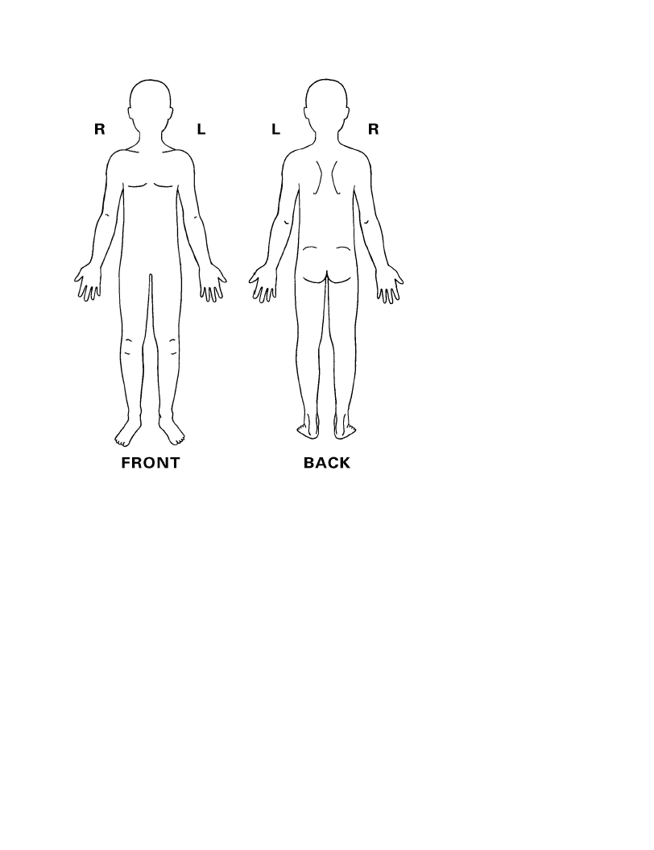
Skin sensation and pressure sore risk
Loss of sensation | Immobility |  | Incontinence
Poor skin integrity | Heat |  | Moisture
Poor sitting posture | Previous pressure sores |  | Overweight
Underweight | Poor nutritional status |  | Smoking
Medication | Substance abuse |  | Cognition
Diabetes Mellitus |  | Other systemic conditions
Details on current and previous pressure sores

ROM screening for sitting (Do assessment in supine)
NOTE: Shaded blocks indicate the need for temporary supports
(unlevel pelvis with and without IT’s weight-bearing, pelvis in anterior tilt, unilateral and bilateral limited hip flexion).

Pelvis, Spine and Neck
 | Neutral | Deviation | Indicate deviation |  | Range/Comments
Is the pelvis: | Level | Tilted sideways | Left side higher | Right side higher
Is the pelvis: | Level | Anterior tilt
Is the pelvis: | Not rotated | Rotated | Left side rotated forward | Right side rotated forward
Is the pelvis: | Under shoulders | Shifted | Shifted to left | Shifted to right
Is the spine: | Straight, symmetrical | Side flexed | Left side flexion | Right side flexion
Is the neck: | Straight, symmetrical | Side flexed | Left side flexion | Right side flexion
Is the neck: | Not rotated | Rotated | Rotated to left | Rotated to right

Lower Limbs:
 | Neutral range | Yes | No | Indicate deviation. Document range
Left hip | Flexion (90-100) |  |  | Less than neutral | More than neutral
Left hip | Ab-/adduction |  |  | Abducted | Adducted
Left hip | Rotation |  |  | Internally rotated | Externally rotated
Right hip | Flexion (90-100) |  |  | Less than neutral | More than neutral
Right hip | Ab-/adduction |  |  | Abducted | Adducted
Right hip | Rotation |  |  | Internally rotated | Externally rotated
L knee | Flexion (75-90) |  |  | Less than neutral | More than neutral
R knee | Flexion (75-90) |  |  | Less than neutral | More than neutral
R foot | Dorsiflexion |  |  | Plantar flexed | Dorsiflexed
R foot | Ev-/inversion |  |  | Everted w/wo add/abd | Inverted w/wo add/abd
L foot | Dorsiflexion |  |  | Plantar flexed | Dorsi flexed
L foot | Ev-/inversion |  |  | Everted w/wo add/abd | Inverted w/wo add/abd

Hand Simulation (Assess sitting. Use temporary supports as indicated above.)
Describe/draw/add a picture of the final posture at the final hand simulation. Describe/indicate support needed.
Circle appropriate temporary support for pelvis and hips:

None Build-up for un-level pelvis L/R Anterior pelvis tilt support Build-up for limited hip flexion L/R Build-up for hip flexion more than neutral L/R

Anterior view | Lateral view | List Posture Support Device (P.S.D) components

Lower limb ROM screening for standing (Assess in supine and side lying)
NOTE: Shaded blocks indicate risk factors or special considerations for standing
 | Neutral range | Yes | No | If no, tick the best description. Document the degree of limitation
Left hip | Dislocated
Left hip | Extension (check in side lying)
Left hip | Rotation |  |  | Internally rotated | Externally rotated
Right hip | Dislocated
Right hip | Extension (check in side lying)
Right hip | Rotation |  |  | Internally rotated | Externally rotated
L knee | Extension
R knee | Extension
R foot | Flat foot (neutral) |  |  | Plantar flexed | Dorsiflexed
R foot | Ev-/inversion |  |  | Ev w/wo add/abd | In w/wo add/abd
L foot | Flat foot (neutral) |  |  | Plantar flexed | Dorsiflexed
L foot | Ev-/inversion |  |  | Ev w/wo add/abd | In w/wo add/abd

Basic prescription of wheelchair/seating system/positioning device
Type: Propulsion | Manual wheelchair |  |  |  |  | Attendant propelled |  |  |  | Power
Type: Environment | Urban |  |  |  |  | Hybrid |  |  |  | Rural
Type: Manual frame type | Basic folding frame (no tilt/recline/armrest adjustability) |  |  |  |  | Adjustable folding frame |  |  |  | Rigid frame 4-wheeler
Type: Manual frame type | Rigid frame 3-wheeler |  |  |  |  | Posture support chair |  |  |  | Positioning device
Type: Power frame type | Basic frame |  |  |  |  | Adjustable folding frame |  |  |  | Posture support frame
Back angle | Recline |  |  |  |  |  |  | Not adjustable |  | Forward | Back (recline)
Back angle | Tool adj. |  | Manual adj. |  |  | Power adj. |  |  |  | Forward
Tilt | No tilt needed |  |  | Yes, tilt needed:
Tilt |  |  |  | Fixed tilt |  |  | Tool adj. |  | Manual adj. |  |  |  | Power adj.
Backrest height | Low |  |  |  | Medium |  |  | Standard |  |  |  | High
Rear wheel position | Manual chair: |  |  |  |  |  |  | Powerchair drive wheel:
Rear wheel position | Front/active |  | Middle/neutral |  |  | Back/safe |  | FWD |  | RWD | Other
Options for stability | Yes | No |  |  | If yes, specify:
Options for mobility | Yes | No |  |  | If yes, specify:

Cushion | Flat base | Contoured base |  | Circle: thick/thin pressure care
Cushion | Pressure relief | Posture support |  | Abduction block
Cushion | No abduction block | Inside thigh wedge |  | Outside thigh wedge(s)
Cushion | Off-set abduction block (left) |  | Off-set abduction block (right)

Back support system | Tension adjustable | Rigid adjustable |  | Modular adjustable
Back support system | Tension adjustable with rigid side supports
Arm support | Armrest |  | Tray table
Arm support | Circle: Yes / No |  | Circle: Yes / No
Head support | Yes |  | No

Complete product specific ordering form/s to complete the prescription and attach to this assessment
List modifications or customisations required (please complete customisation drawings on a separate Word document where applicable)

Client seating level | Basic | Intermediate | Advanced
Technical level | Basic | Intermediate | Advanced

Completed by:

Name: ______________________________________ HPCSA number: _______________

Signature: _______________________________ Date: ________________________

Approver signature
Date

